Britain at War | Class: Oaks  Term: Autumn
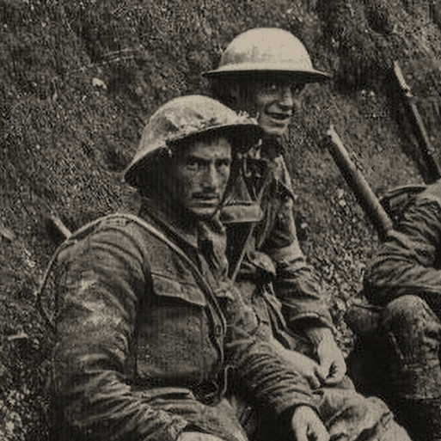  Driver Subject: History  This project teaches children about the causes, events and consequences of the First and Second World Wars, the influence of new inventions on warfare, how life in Great Britain was affected and the legacy of the wars in the post-war period. | Science  Light Theory  Habitats, Evolution and Inheritance  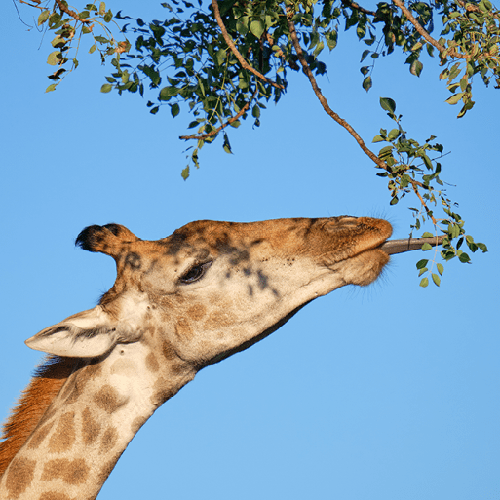  
English
Non-Fiction Letter from a fairytale character
Non-Fiction Goldilocks - newspaper report
Poetry Ten things found in a soldier’s pocket
Non-Fiction Letters from the Light House - Evacuee Recount
Narrative The Christmas Truce – Historical Story
Maths
Place Value
Addition and Subtraction
Multiplication and Division
Fractions
Geography
Our Changing World Part 1 - Features of Earth including the Arctic and Antarctic Circles; Time zones, Latitude and longitude; Map scale; Grid references, contours and symbols; Climate change, extreme weather and people; Worldwide trade; Natural resource management; Road safety; Fieldwork; Settlement patterns; Local enquiry
Religious Education
Why is the gospel such good news for Christians?
How do questions about Brahman and Atman I’ - influence the way a human lives?
Art and Design  Bee, Beetles and Butterflies - Using sketchbooks; Observational drawing; Mixed media collage; Pop Art  Distortion and Abstraction - Abstract art; Abstraction by line, colour and shape; Significant artists – Pablo Picasso, Robert Delaunay and Sonia Delaunay; Orphism | D&T  Make Do and Mend - Investigating clothing; Sewing – running stitch, whip stitch and blanket stitch; Repairing clothes; Making products from recycled material
Computing  E-Safety  Data and information – introduction to spreadsheets | Music  Keep the home fires burning - Music from WWI, fanfare, triad, rhythm, dot notation  Balinese gamelan - Gamelan from Bali, interlocking rhythms, vocal chant, structure
French  Phonics  The date  Clothes | P. E  Rugby  Netball  Gym  Forest School

These activities are for you to do at home. You can do all of them or choose the ones that you find most interesting.

What will you choose to do?
1. Use your existing knowledge and a range of sources to write a report about the First World War. Record information as notes on a mind map first, under headings such as causes, warring nations, key events, front line, home front and how the war ended. Use your mind map to help you write your report. Include a title, an opening paragraph, a timeline of key events, subheadings, detailed facts, precise topic vocabulary and images with captions.
2. Use a range of sources to look at images of First World War trenches. Find out about trench warfare and then answer the questions. • Why were trenches used during the First World War? • What did trench warfare involve? • What was life like for the soldiers in a First World War trench?
3. Use a range of sources to find out about the following important events, which involved Britain during the Second World War: Battle of Britain, the Blitz and D-Day. Use bullet points to write a list of key findings about each event.
4. The Ministry of Information produced persuasive posters during both the First and Second World Wars to affect people’s opinions and actions. Use online sources to learn more about wartime posters and to find examples. Then answer the questions. • What was the purpose of persuasive posters in the First and Second World Wars? • Propaganda was a feature of some wartime posters. What is the definition of the word propaganda? • In what different ways did posters encourage British people to get involved in the war effort during the First and Second World Wars? • Choose some wartime posters to explore and answer these questions: Who was the poster aimed at? What was it meant to achieve? How effective do you think it was and why?
Useful websites
Britannica Kids – Norman Conquest
Britannica Kids – Wars of the Roses
Britannica Kids – English Civil War
DKfindout! – Facts About The Napoleonic Wars
Britannica Kids – Crimean War
BBC Bitesize – World War One – KS2 History
BBC Teach – World War Two
Imperial War Museums – Living in the Trenches
Britannica Kids – Battle of Britain
Britannica Kids – Blitz
Britannica Kids – D-Day
BBC Teach – How propaganda was used during World War Two – History KS2
Imperial War Museums – Second World War Posters

